Overdale Community Primary School – Nursery Spring term 2 2025
Theme: People who help us?
  Specific Area: Literacy  Talk for writing focus text – The Gingerbread man  Other focus texts- ‘Where’s Spot?’ ‘Come On Daisy’  This half-term we will continue with our daily phonics sessions  The older N2 children will continue to consolidate their understanding the sounds they have already learnt. Our new sounds will be: u, r, h, b, f, l  N1 children will be continuing to tune into environmental and instrumental sounds by playing a variety of listening and attention games.  We are continuing to support the children with their name recognition as well as providing opportunities for them to practise ordering the letters in their name. We are also practising name writing weekly for those children who are ready to do so.  We will be using Talk for Writing to develop our story telling and to create our own stories  This half-term our focus will be on the setting of the story. We will be innovating our stories so that the Gingerbread man has a different obstacle to overcome. |  |   Specific Area: Mathematics  White Rose maths with Master the curriculum  Counting- We will be learning to tak objects from a group and to give/ take 1, 2, 3 items from it.  Subitising- We will be learning to subitise 3 and talking about dots. The children will learn to recognise 1, 2 and 3 dots in different arrangements.  Comparison: We will be noticing when two collection are the same and making our own small collections, learning the vocabulary to be able to talk about them.  Shape, space and measure- We will be learning to match shapes using a range of materials and exploring the words ‘same/ different’. We will also be following simple routs inside and outside.  Easter patterns- we will be learning to recognise simple patterns. We will also be copying and extending simple A/B patterns.
  Specific Area: Knowledge and Understanding of the World  Our Key question is ‘Which people are special and why?  We will begin our investigations by exploring people at home who are special to us. We will then open this out to people in school who help us, moving on to people in the community who help us. We will be inviting a range of visitors from our own school community, as well as the wider community, to share how they help us.  We will continue to explore Winter and the changes which happen at this time. This will move onto exploring the Spring equinox and the changes which come with the Spring weather. | People who help us  BIG QUESTION  Who helps us at school and in the community? |  | Specific Area: Physical Development  The children will continue to develop their fine/ gross motor skills, pencil grip, pencil control and scissor skills through a range of weekly activities set out in the classroom. We will also continue to support the children in zipping up their own coats. They will also be taking part in whole class Dough Disco and ribbon dancing activities.  You can support us at home by practicing these skills at with your child e.g. encouraging your child to use correct pencil grip when mark making, helping to peg clothes onto washing lines, completing peg jigsaws, visiting places which allow children to run/ climb/ jump/ skip etc.
Specific Area: Personal and Social Development (PSED)  Each half-term we focus on an aspect of our school values. This half-term we will be exploring ‘resilience’  We will take part in circle time activities which look at: careful listening, perseverance and self-regulation  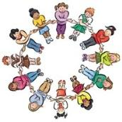  We will also be re-emphasising the importance of good oral health, making healthy choices as well as encouraging them to become even more independent in meeting their own care needs. Support us at home by encouraging them to dress/ undress independently, zip up their own coats | Prime Area: Communication and  Language  We will be continuing with our ‘Word aware’ sessions each week, where the children are introduced to a concept word to explore. These will also be shared on class Dojo with activities to support with at home. Support us at home by using and exploring these words in context when talking and playing with your child.  There will also be a nursery rhyme which we focus on each week.  As part of our ‘Talk for Writing’ sessions, the children will be learning to re-tell the story of the ‘The Gingerbread man’. Support us at home by encouraging your child to perform this at home. |  | Specific Area: Expressive Arts and Design Music  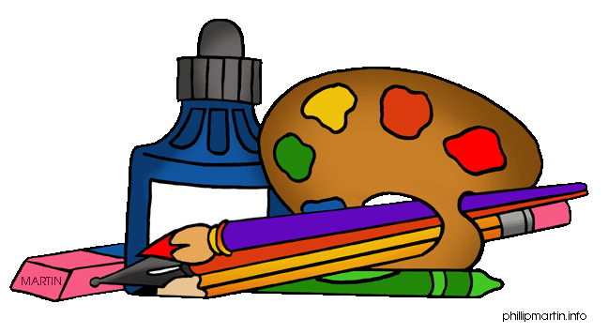  This half term will be exploring rhythm in music and dance by playing a range of dancing, listening and rhythm games.  We will also be learning how to build using the resources in the workshop for a purpose. E.g. we will be expecting the children to create models from the junk modelling and other materials and that their models represent what they set out to create.

We will be sending home books from our ‘borrow box’ this half-term. We encourage children to read at least 3 times per week. We will also be sending home reading records for you to fill in each time you share any book with your child. We like to know what your child likes to read at home, so please add these to the record and we can also share them with them at school.
Dojo profiles – Please remember to send us photos and videos of what your child is doing at home – anything from walking the dog, swimming, playing in the play park, baking etc – we can’t wait to see your photos

